Please complete form below and submit for approval in order to return AFCI breakers.
All columns must be completed, for each breaker being returned.
Please return form to local Siemens Distributor Rep.
AFCI returns will not be accepted without prior approval a Siemens Representative.
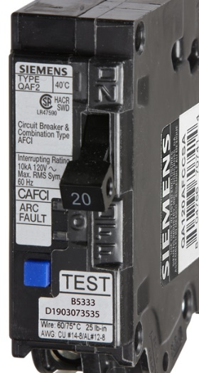
Date Code: D1903073535

Contractor Name | Phone Number | Part Number | Date Code | Load on Circuit – Make, Model etc
Smith Contracting | (123) 456-7899 | QA115AFCCSA | P2003091234 | “Brand” “Appliance”, Model #

