SweetProcess: Template for Documenting Procedures
With this template you can document procedures in Microsoft Word and then upload the procedure to SweetProcess.
Or you can just use it as a standalone template. As you read the steps below you’ll learn more about what this template can do, and also what SweetProcess can help you with in documenting your systems.

❶ This is Step 1
This is where you put the instructions related to the first step of some workflow or procedure. Just so you know, the definition of a “procedure” is a step-by-step workflow. You could call it a “process” but the proper definition of a process is that it’s a group of related procedures.

❷ Insert Step Title Here
And whatever you need to say about step #2 goes here. Remember, whenever you see a list of numbered steps you’re looking at a procedure. As opposed to a policy which looks like this.

❸ Insert Step Title Here
If you want to, you can insert bullet points lists like this
- Bullet #1
- Bullet #2
- Bullet #3

❹ Insert Step Title Here
You can also insert numbered lists like this
- Thing #1
- Thing #2
- Thing #3

❺ Insert Step Title Here
Being able to explain things with screenshots is very helpful. And with SweetProcess you can insert a screenshot like this
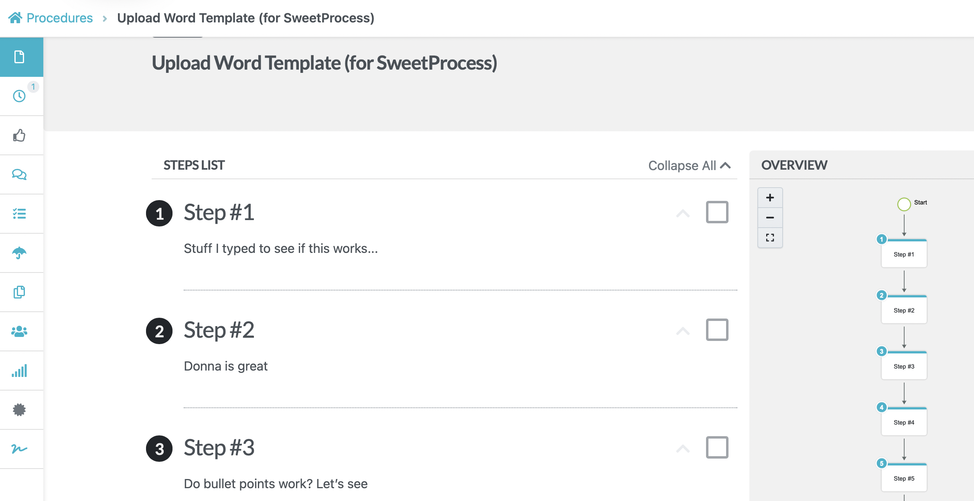

❻ Insert Step Title Here
The thing to realize is that it’s important to break things down as much as possible, especially for important steps that might be misunderstood by someone doing it for the first time.

❼ Insert Step Title Here
Most procedures don’t need more than a few steps, and if so that’s fine. Even if it only has two or three steps, you should still document it. But, if you get to needing seven steps then obviously it needs to be documented carefully using text, bullet points, numbered lists, screenshots, or even video.

❽ Insert Step Title Here
SweetProcess lets you embed videos if they’re hosted elsewhere. If you want to upload it to SweetProcess then the video needs to be no more than 52 MBs. That’s not going to let you upload many videos, so don’t plan on using SweetProcess to host your videos.

❾ Insert Step Title Here
The best tool to use to create, share and host videos is Loom. It’s free for up to 100 videos, but the videos can’t be more than 5 minutes long. If you pay to use Loom then you can record longer videos and do a lot more. The cost is $10/month and it’s worth it.

❿ Learn More About Systematizing Your Practice
If you want to learn more about using SweetProcess then check out this 4-week workshop called Law Firm Systems.
The workshop teaches solo and small firm lawyers how to map out workflows, and document them using SweetProcess.
To see examples of procedures created in SweetProcess click here.

